KFS LOOKUP
Current Account Balance
On the KFS Main Menu, select Current Account Balances
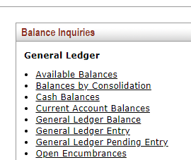

Enter the Fiscal Year, Fiscal Period, Chart, and Account. Click Search.

Note: Fiscal Period 1 = July, Fiscal Period 2 = August, Fiscal Period 3 = September, etc.

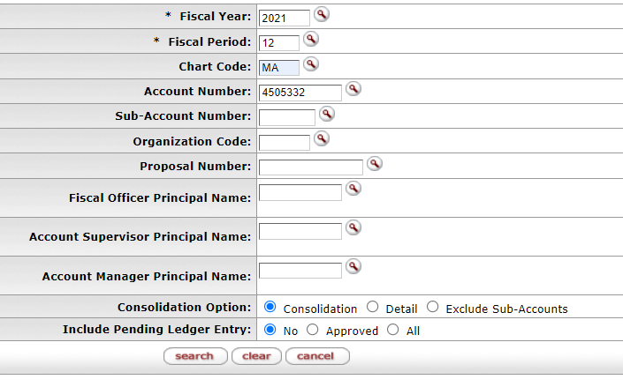

Your Available Balance will be displayed.

