UH eProtocol Investigator User Manual

For use by Investigators, Study Coordinators, and Research Administrators in navigating and submitting a research application to the UH IRB using the eProtocol application system.

Logging into the UH eProtocol interface/portal
The eProtocol system uses the Central Authentication Service (CAS) administered by the UH ITS. This means, to log onto the the eProtocol portal, you will use your UH email username and password.
The url for the eProtocol portal is https://uhmanoa.keyusa.net
Once on the site, you will automatically be redirected to the UH ITS site to authenticate your username and password. All users of the portal must have a UH username. If you do not have a UH username, but still need to access the eProtocol, please contact the Human Studies Program at 956-5007 or uhirb@hawaii.edu

The Investigator Home Page
Once logged in, you should find yourself on the Investigator Home page. You will automatically be signed in as an Investigator, even in situations where your role on a given project or projects, is as a coordinator, manager, or a student – co-investigator. This will allow you to view and edit applications. Something to keep in mind, is that the eProtocol program automatically allows access only to parts of an application, based on the permissions associated with your role on that project.

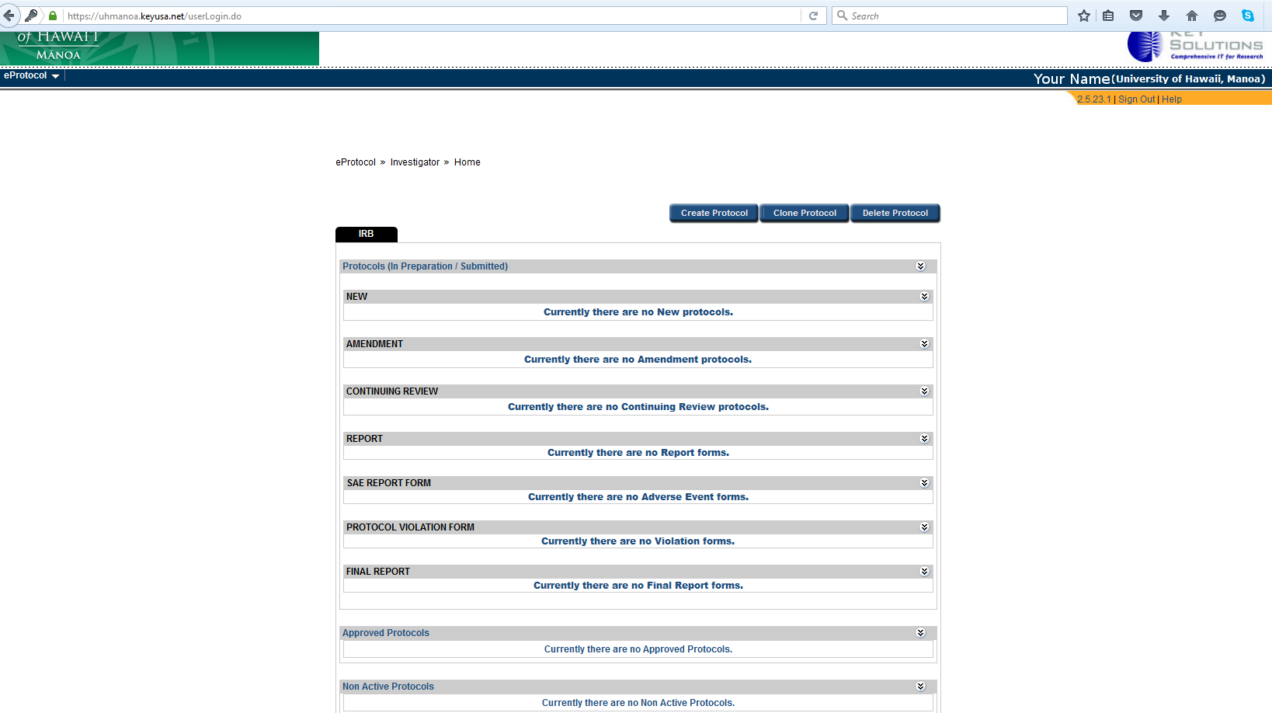

At the top right corner of the webpage, you should see listed your last name and your University affiliation. Under this, is the link to sign out, and a help link. The help link will open a new webpage with an online version of this manual.
At the top left of the page, there is the eProtocol link. Hover your mouse over this link, and you will see a drop down menu.
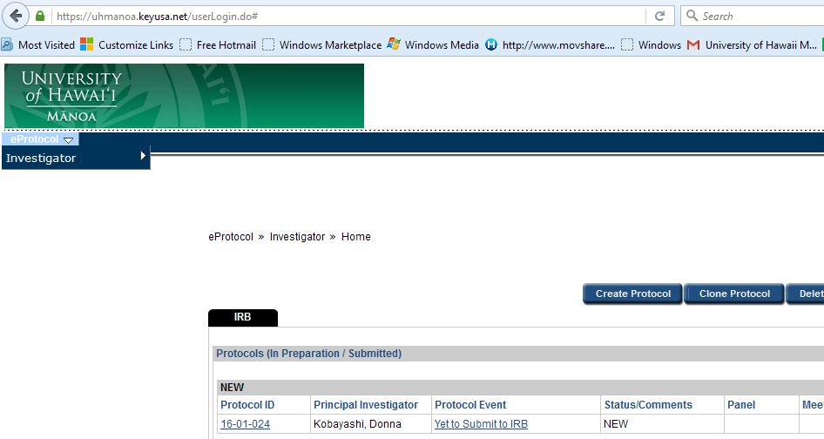

Hovering your mouse over “Investigator” will open a second menu. 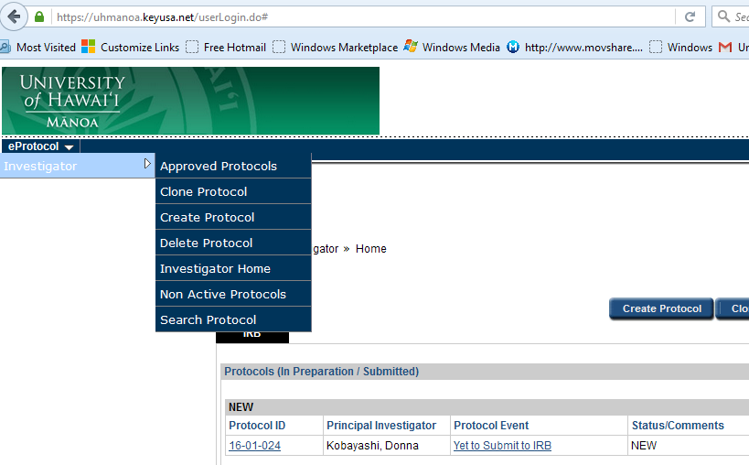
This menu contains various tools.

Approved Protocols
Clone Protocol
Create Protocol
Delete Protocol
Investigator Home
Non Active Protocols
Search Protocol

The information presented in the main portion of the page, will depend on the tool you have selected. The default listing, when you first log on, is one long list of all protocols on which you are listed as an investigator. This would include protocols that list you as a coordinator, manager, or co-investigator. For researchers with numerous protocols, this may present a daunting list to search through. eProtocol offers several methods to simplify and manage your listing. For instance, selecting “Approved” will limit the list to protocols that have already been reviewed and approved by an IRB.
Clone Protocol and Create Protocol are both ways to start a new eProtocol/IRB application. You can launch these tools both from the menu, and from the links on the Investigator Home page. Search protocol allows you to list a single protocol, or a list of protocols given a number of criteria.

Creating a New Application/Protocol
There are two ways to launch the “Create Protocol” window.
The Investigator Menu, | Or the Create Protocol button on the Investigator Home Page.
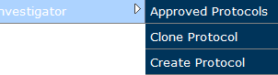 | 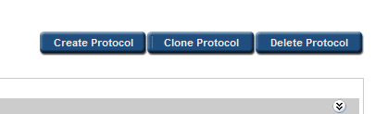

The first page brought up is not part of the application, but is to basically register the PI and the study/protocol title. Once you complete this page, you will have created an eProtocol application/entry, and your protocol will be assigned its unique ID.
You can list someone other than yourself as the Principal Investigator (which you will need to do as a student researcher). eProtocol will require that you list yourself as the 2nd Investigator or contact. You need to do this regardless of whether you are actually an investigator (for example, if you are a study coordinator). You can change your role on the Personnel page immediately following. Your study/protocol information will be saved each time you save, or click next to exit the page.
Note: The “Unified IRB Form” is the IRB application. This same form will be used for This button will remain checked for all new applications, as well as renewal and modification requests.

Personnel information
Be sure to answer the student research item at the top of the Personnel Page.
As noted above, you may revise the roles of study personnel on this page. For example, if you have listed yourself as Principal Investigator, but realize now that you need to list your faculty advisor in this role instead, you can make that change on this page.
You will need to select study personnel by clicking on the drop-down menu icons, to bring up the personnel search panel. All study personnel must have a UH username. If you wish to add study personnel without a UH username, you need to contact the HSP office.
The Study Coordinator and Administrative Contact entries are optional. Some researchers are part of programs or Departments where there will be a person or persons given this role. If it does not apply to you, simply leave these blank. An investigator may also be listed as Administrative Contact.
The CITI training information should automatically download to your application. If it does not, you need to print out a copy of your completion certificate, and attach it to your application (on the attachments page).
The HSP program does accept NIH training, in lieu of CITI training, but only for NIH funded research.

Subject checklist
Please select all populations (and only those) that are specifically targeted for this study. Subjects that may be included, but are not targeted should not be selected.
For example, A researcher conducting a study designed to recruit both male and female subjects may recruit pregnant women as subjects, However, pregnant women should not be checked as a study population unless the researcher plans to target pregnant women as a focus population.
Be sure to carefully review responses on the “Subject Checklist”. Selected items on the subject checklist, such as “Prisoners” or “Pregnant Women” may Comment, checking will open up additional items in the application. Omitting these items may cause delays in the review process.

Study location
The study location is the location at which the research takes place. For example, a study in which specimens are collected at a community clinic, and analyzed at UH Hilo, should have both UH Hilo and Other selected.

General checklist
Section 5 "Relying IRB" references research conducted in collaboration with another institution. Select these entries only if another Institutional Review Board will be reviewing this research, or if another Institution is requesting that the UH IRB serve as the IRB of record.

Application type
Select the option you believe applies to your project. If you check Not Human Subjects or Exempt, portions of the application form will be disabled/grayed out. You will not be able to enter information into these sections. If it is later determined that your protocol does not meet the criteria for Exempt Research or Not Human Subject Research, you will need to redo the application addressing those sections. When in doubt, you should select Not-exempt. HSP staff will process a “non-exempt” application as exempt if they determine it meets the criteria.
Please refer to the Human Studies Program website for more information.
https://manoa.hawaii.edu/researchcompliance/human-studies

Protocol information
Sub-Sections: You may navigate quickly through your application using the menu on the left side of the protocol window. Clicking on “Protocol Information” will expand the menu to open up additional sub-sections.
If you are unsure whether your research qualifies for Expedited review, you may simply skip this section. HSP staff will make this determination.
When addressing consent and assent information, you may also attach your consent and assent documents. Be sure to scroll down to address additional items in the Consent attachment pop-out window, as appropriate.
On the attachments page, remember to include a protocol attachment, any consent and assent forms that were not already attached, as well as flyers/recruiting materials and study instruments, as appropriate. Try to clearly but concisely label your attachments. eProtocol will save all attachments, making subsequent revisions easier to track, however, a clear labeling scheme will make this easier on you, and reviewers.
If a section of the application is grayed out, that should not be, such as HIPAA or Drugs and Devices, you may need to revisit and revise responses on the General Checklist, to enable them.
If the COI section is grayed out, but you need to notify the IRB of a COI, you may just add an attachment to address this.

Check for Completeness
When you are ready to submit your application, you will need to select the “Check for Completeness” tool, to verify there are no outstanding items or issues. Please note, this will bring up another pop-up window. If there are multiple windows open on your computer, you may need to look behind some to find the window. If there are outstanding issues, these will be listed in the “Check for Completeness” tool. You may navigate to these sections using the regular menu, or the “Check for Completeness” tool.

Incomplete
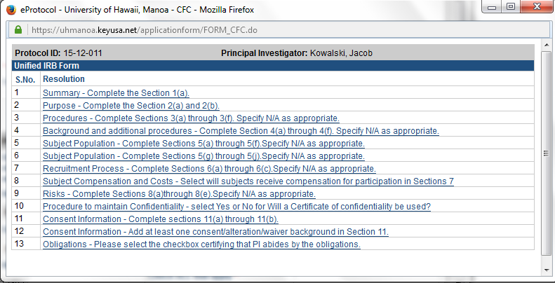

Complete
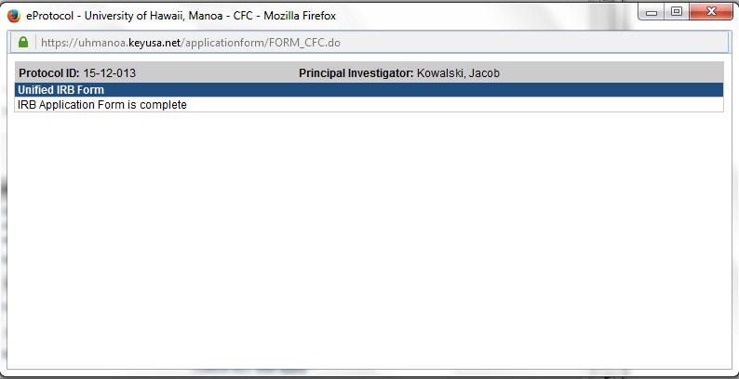
Once all items have been addressed, you will be able to submit the application for review.

Submitted Application
You will receive email notification on successfully submitted your application. Once an application has been submitted, you will no longer be able to edit that application. HSP staff may respond with requests for clarification or additional attachments. This “cycle” of correspondence will open the application, or portions of the form, for your edit again. There may also be correspondence from the IRB reviewer, which will also require additional attachments or clarification. Please note, however, other than in response to HSP correspondence, if you need to make revisions to your application, you will need to withdraw the application. To do this, you would need to communicate with HSP staff directly. This will apply renewals and modification applications as well.
Notification of approval will be via email.

